Text on Microsoft.com

A HOT Evaluation by Pat Kusch
(Pat’s comments written in maroon)

Brevity

Purpose
To determine the extent to which the text on this site achieves the brevity needed for effective online presentation.
Brevity makes text sink in, online.
To achieve brevity, though, a writer must adopt half a dozen strategies, and within those broad approaches, a number of tactics. Writing a short article takes more effort than going long. The strategies are:
Strategy 1: The language is terse.
Strategy 2: The paragraphs are short..
Strategy 4: Tangential material is moved out of the way.
.
These strategies and tactics for brevity appear here as a set of guidelines based on research and actual experience, documented in books, journal articles, and online style-guides. (References appear at the end of each strategy). Each guideline, then, provides a method for a writer to follow, or a heuristic.
In this evaluation we test the text against these guidelines. This, then, is a heuristic evaluation.

Samples are selected from the home page and located on the left sidebar

Sample # 1: Product Families
Subject: Why upgrade to Microsoft XP?
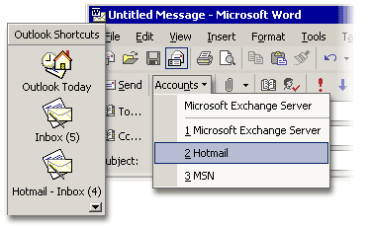
Paragraph: Manage All Your E-Mail in One Place
Microsoft Outlook® is your complete personal-information management and messaging solution. Consolidate multiple e-mail accounts, including those on MSN Hotmail®, and send and receive instant messages with MSN® Messenger—all within a single view.
Learn more about consolidating e-mail accounts in Outlook.
URL to the page: http://www.microsoft.com/office/evaluation/tour/page3.asp#documents
Date investigated: August 27, 2002

Every reason for upgrading had a graphic were applicable. Hot links to explanations and additional information were imbedded in each sentence close to the end. Text was chunked into easy readable two to three sentence form. The graphics also moved showing the reader exactly how the application looks and feels. Nicely done.

Sample # 2: Resources
Subject: Support Help, Search the knowledge base
Paragraph: How to Search for Downloads

If you know the name of the file you want to download:
- In the Search for box, type the name of the file you want to download. For example, type Oxpsp1.exe.
- In the Select a Microsoft Product list, select Office XP Suite.
- Click Go.
You can also click Find & Download Software on the Support Menu to search for files you want to download.

URL to the page: http://support.microsoft.com/?scid=fh;[ln];kbhowto
Date investigated: August 27, 2002

Sample # 3: Information For
Subject: Journalists
Paragraph: August 26, 2002 6:00 a.m. PDT
More for Less: Server Appliances Help Companies Expand Networks
Smaller in scope and function than general purpose servers, Windows Powered server appliances match devices to tasks, helping businesses boost efficiency and lower costs.

URL to the page: http://www.microsoft.com/presspass/default.asp
Date investigated: August 27, 2002

Sample # 4: About Microsoft
Subject: Careers by Microsoft location. I selected Fargo, ND (Great Plains acquisition)
Paragraph: Paragraph #2--What We Do
Located in Fargo, North Dakota, Microsoft Great Plains Business Solutions produces cutting-edge business software that helps small and mid-sized companies stay agile in today's interconnected economy. Its products are designed to automatically manage an array of business-critical operations, from financials, distribution, and human resources to manufacturing, supply chain, and e-commerce. The products also allow Microsoft customers to securely share information online with employees, customers, suppliers, and partners.
Paragraph #5 -- About the Area
When the two sister cities teamed up a few years ago, they were selected as an All- American City, a distinction based on many factors. The air and water are clean, the crime rates are low, and the people are friendly. Recently, several magazines proclaimed Fargo-Moorhead to be one of America's most stress-free metropolitan areas. And then there's the climate: pleasantly warm summers and dry winters, with the sun shining approximately 55 percent of the time. Residents are just minutes away from hundreds of lakes, and the region offers top-notch fishing, hunting, Nordic skiing, snowmobiling, and other outdoor activities. Many Microsoft Great Plains employees live outside the urban area, opting to commute the short distance to town.
URL to the page: http://www.microsoft.com/careers/greatplains.htm
Date investigated: August 27, 2002
The pages about Fargo North Dakota and a more Midwest feel. The language is homey and more conversational than the Redmond or international pages language.

Sample # 5: Worldwide
Subject: Worldwide information appears a map and I selected Australia.
Paragraph:
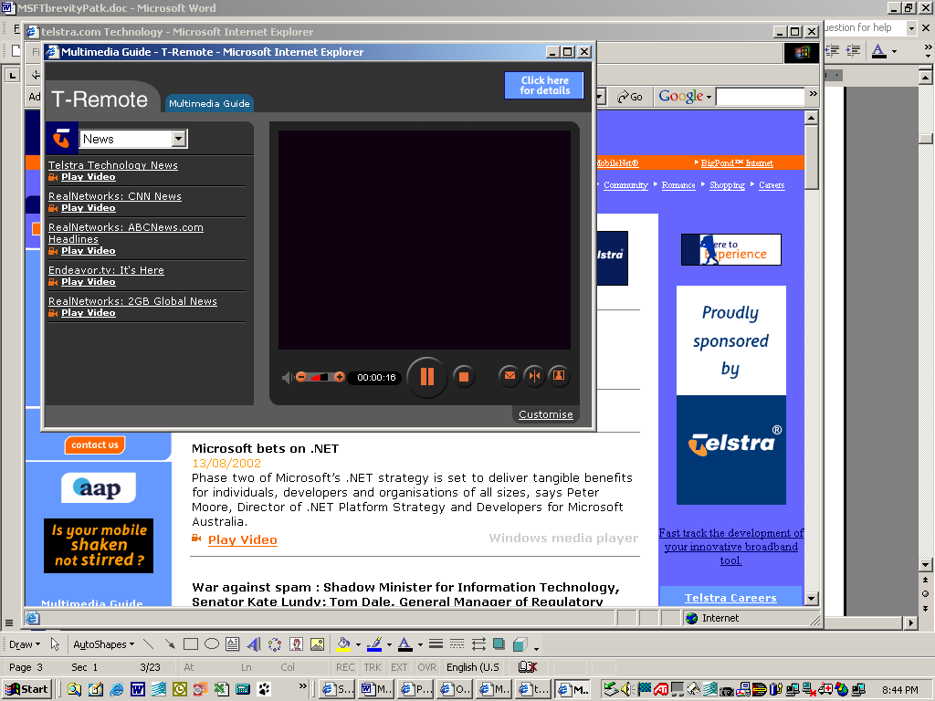
Microsoft bets on .NET13/08/2002
Phase two of Microsoft’s .NET strategy is set to deliver tangible benefits for individuals, developers and organisations of all sizes, says Peter Moore, Director of .NET Platform Strategy and Developers for Microsoft Australia.
Play Video
URL to the page: http://www.microsoft.com/Australia/ then tunnel down to the next layer to http://telstra.com/technology/techNewsArchive.asp#
Date investigated: August 27, 2002

Evaluation

Strategy 1. The Language is Terse.

Nothing is repeated except where the context demands repetition.
Test
In each sample paragraph, I found only one or two repeated words or phrases, or none.
YES=1, NO=0.
Impression
Overall, did the running text seem free of repetition?
YES=1, NO=0.
Example
Which paragraph seemed particularly repetitious (if any)? I found almost no repeats. Links were interlinked when needed.
Comments I found very little repeated in the text. The pages themselves were similar in font type and the Microsoft blue color. However, every page had a different layout style and message.

The text is generally free of unnecessary adjectives and adverbs.
Test
In each sample paragraph, I found only one or two adjectives or adverbs that could be removed, without changing the meaning of the text.
YES=1, NO=0.
Impression
Overall, did the running text seem free of adjectives and adverbs?
YES=1, NO=0.
Example
Which paragraph seemed particularly flowery (if any)? (Sample # 4 about careers at Microsoft. Cruising the other career locations the voice seemed to change to fit the prostective audience. i.e. Redmond was more “exciting” than say Nigeria.
Comments I tried to find a slip up in the selection of words or phrases. At the Australia site in sample # 5 the tech writer either is Australian or at least knows that British English uses [s] instead of [z] in organization. I was delighted that the site would take this into consideration. A++

The text does not take more than a phrase to establish context at the beginning or end of a paragraph or sentence.
Test
In each sample paragraph, I found only one short phrase or clause establishing context, or offering a transition.
YES=1, NO=0.
Impression
Overall, did the running text seem free of lengthy transitions or context-setting?
YES=1, NO=0.
Example
Which paragraph seemed particularly burdened with transitional material (if any)? None seemed verbose.
Comments Most paragraphs were one sentence or a fragmented phrase. Each frame of the page which over-laid was in a logical thought process for the reader—even the downloads and “how to” page on Support Help.

There are few phrases that could easily be replaced with single words.
Test
In each sample paragraph, I found no more than a single phrase that could be replaced with a word, without changing the meaning of the text.
YES=1, NO=0.
Impression
Overall, did the running text seem free of junk phrases?
YES=1, NO=0.
Example
Which paragraph seemed particularly full of deadwood (if any)? None found and believe me I tried. After an hour of searching I gave up.
Comments These prose have been picked clean. Maybe when I learn more I can spot some areas of improvement.

One-or-two syllable words make up the bulk of the words.
Test
In each sample paragraph, I found that one-syllable words and two-syllable words made up the majority of the text.
YES=1, NO=0.
Impression
Overall, did the running text seem built on words of one syllable?
YES=1, NO=0.
Example
Which sentence seemed particularly straightforward because of its one-syllable words (if any)? The following Search options are available: and then the site list title of the categories in black bold and the definition of the option in plain face. I could not tell how complete the options selections were. Such as, was everything there that may be needed by the reader/client/customer?
Comments Many of the pages used technical terms that a non-computer savvy person would not understand. I think this was a conscience decision. This was the inexperienced will call a local tech support person or Microsoft’s telephone support for big bucks per minute or per call. $$

In each paragraph, at least one key word describes a physical thing or an act.
Test
In each sample paragraph, I at least one word describing a physical object, or a concrete action.
YES=1, NO=0.
Impression
Overall, the writer often chooses words that refer to tangible, visible, common objects, or activities.
YES=1, NO=0.
Example
Which paragraph seemed particularly concrete (if any)? Sample #2. The structure was clean clear with plenty of white space and bolding of titles and action required buttons.
Comments When step-by-step directions were give bolding and numbers were used to highlight the steps. Also the directions were mostly on a single screen (at least on my PC—it is set at 1024 X 768 pixels size.)

In general, the writer has chosen the familiar or frequently used word over the rare or unfamiliar one.
Test
In each sample paragraph, the writer generally used familiar terms, not strange jargon, and words that are common, rather than unusual. (Of course, if the writer is explaining a strange concept, we want to see it explained in simple terms).
YES=1, NO=0.
Impression
Overall, did the writer choose commonly used words over jargon?
YES=1, NO=0.
Example
Which paragraph seemed particularly prone to unfamiliar, or uncommon language (if any)? None.
Comments The worst for jargon was the company profile for the stockholder. Great market speak. The page on legal responsibilities was by its very nature filled with legalese.

Strategy 2. Paragraphs are short.

Each paragraph has four sentences or less.
Test
On average, the sample paragraphs have four sentences or less.
ONE SENTENCE= 4, TWO SENTENCES = 3, THREE SENTENCES = 2, FOUR SENTENCES = 1, MORE = 0.
Impression
Overall, did the writer make short paragraphs?
YES=1, NO=0.
Example
Which paragraph seemed particularly long (if any)? None.
Comments Many of the paragraphs had hyperlinks impeded in them that lead the reader to a definition or another page about a related topic.

Each paragraph focuses on only one main idea.
Test
On average, each paragraph focused on only one main idea.
YES=1, NO = 0.
Impression
Overall, did the writer keep each paragraph tightly focused?
YES=1, NO=0.
Example
Which paragraph seemed particularly unfocused (if any)? None.
Comments Most of the paragraphs were topic sentences. The exception is the careers page when it talks about the attributes of the different Microsoft sites.

In the layout on the site, each paragraph has no more than six lines.
Test
On average, the sample paragraphs have six lines or less on the site.
TWO LINES= 5, THREE LINES = 4, FOUR LINES = 3, FIVE LINES = 2, SIX LINES = 1, MORE = 0.
Impression
Overall, did the writer work within the layout to make paragraphs look short?
YES=1, NO=0.

Example
Which paragraph seemed particularly long on the site (if any)? There were long sections of market speak in the About Microsoft in Sample #2. Luckily, I could skim for content because the writer lead with subject verb in a topic sentence.
Comments The pages were broken up into small select ideas or tasks. This made navigating the site easy. However, you could spend weeks in the catacombs of the site looking for treasure.

Strategy 4. Tangential material is moved out of the way.

Background or supplementary material is linked to, not forced on the users.
Test
If the text refers to background information or specialist details, that material is linked to, rather than forced on the users here.
YES = 1, NO= 0.
Impression
Overall, the writer unfolds information gradually, rather than putting it all on one page.
YES=1, NO=0.
Example
Which paragraph seemed particularly crammed with material that could have been moved to another location? None. This site is huge but if you are familiar with the layout and organization you can move through it in a moderate speed.
Comments If anything the information was on too many pages. Sometimes you would click forever to get to the fact or tidbit on information you were looking for. Many pages had search engines to data bases which helped eliminate clutter within a frame or the overuse of hyperlinks.

When the topic is complex, information is broken up into many paragraphs, sections, or pages.
Test
When the topic seems complicated, the writer uses many small paragraphs, many sections, or pages, rather than pouring it all into one long flow of text.
YES = 1, NO= 0.
Impression
Overall, the writer divides the material up into bite-sized chunks.
YES=1, NO=0.
Example
Which paragraph seemed particularly overloaded (if any)? None.
Comments When the topic was complex Microsoft did not dumb-it-down. The writers made it clear that if you are not comfortable with the directions this is how you call for help. The Download service packages page is a classic example. It gives you one way to down load and assumes there are no problems. 99% of the time this works just fine.

Sample #1 has a screen capture of a flash file that actually walks the reader through what buttons to push. Way cool! The demo makes the New Upgraded software so appealing you will want to go out and buy a copy for everyone you know. There is also music or a voice explaining every feature. Reader views great reasons to upgrade. Very seductive.

When there are multiple links to related stories the links are pulled out of the regular running text.
Test
If there is a set of links to other stories, the links appear in a separate sidebar, a distinct list, or a separate section.
YES = 1, NO= 0.
Impression
Overall, the writer separates link lists from the rest of the text.
YES=1, NO=0.
Example
Which paragraph seemed particularly jammed with links within the running text (if any)? None.
Comments Microsoft did one better. There gave you movies to watch. They reminded me of the trailers the movies would play before the main feature at the movie theater. Microsoft posted on the Australian site (Sample #5) a live interview with the head of the Australian division. Low and behold he even has a aussie accent. A++ on hiring the locals, Microsoft. These films are very much like news releases and are motivational in nature.

All facts and ideas are relevant to the main topic of the paragraph, not extra.
Test
The facts and ideas refer to the main topic of each paragraph.
YES = 1, NO= 0.
Impression
Overall, the writer makes sure that every part of the paragraph relates to the main topic.
YES=1, NO=0.
Example
Which paragraph seemed particularly chaotic, or incoherent (if any)? None.
Comments I believe most of the information is on target and supports the ideas of the topic sentence. This site and these pages come in different languages and I wonder if they are as written and exhibit the technical fluidness of the English version.

Total Score
Assigning a grade to text is always a bit arbitrary. But counting up the points for these sample texts, we reach this diagnosis:
Total Points: 33
Total Possible: 36
Percentage: 92%

Interpretation
90-100%: Excellent brevity.
75-89%: Pretty brief, but occasionally rambling.
60-74%: Could use some trimming.
45-59%: Verbose.
25-44%: Horribly overgrown.
0-24: Grotesque.

Overall Conclusions
This site pretty much has everything including a “Code of Conduct” page. This page emphasizes what corporate Microsoft does not support and the usual waving of hands and appointing themselves blameless should anything happen within the communities groups. http://communities2.microsoft.com/home/rulesofconduct.aspx
The purpose of the site is well defined and employs the Gestalt principles of design
- Good figure-ground contrast
- Grouping and making parts coherent (units and subunits)
- Excellent interweaving of graphics with text (I liked the folder tabs)
- Consistent type face throughout the site
I would like to understand how and why the web writers made the choices in design and content. Microsoft must have a corporate a style guide for its public site and some kind of governing body or control system to scrutinize the content. From personal experience I found the intranet pages, within the company, were not as restrictive nor do they represent the corporate image to the same extent. (I once spent the day at Microsoft as an Intel employee working on chip design) However, the color and the encouragement to use the electronic medium is very strong within the company.

I very much liked all the movies and pictures to educate. The sound bites on products and movies highlighting people added a personal touch and were very persuasive.

I like using the HOT form. The form helped me take a more critical look at the individual parts that make-up the whole of the site. Excellent prompting for thought.

Major Recommendations
I found no glaring problems. The massiveness of the site usually would make it cumbersome but I did not find that to be true.
My only suggestion is to divide the site up if possible…. like the company should do. Implement spin-offs in but keep the good search engines. Lighten up on the logo and the Microsoft blue color and reclaim real estate on the screen. I felt really beat up after a while with the max contract effect (blue headers and light gray background color.)

